**FIRST EDITION OF THE POSTER CONTEST**

ANNUAL MEETING OF THE MED YOUTH NETWORK

MARSEILLE, 24-27 NOVEMBER 2021

Registration form and rules of participation

*On the occasion of its next annual meeting which will take place from 24 to 27 November 2021 in Marseille (France), the Med Youth network invites young artists from the Mediterranean to participate in the first edition of the competition whose objective is to create the poster of the meeting. Ten posters will be exhibited in Marseille on the occasion of the meeting and on the network's website. The three best posters will be ranked and three artists will be awarded. The winning poster will be used for the meeting.*

*Get your pencils, draw, go!*

**This registration form must be completed, signed and returned by email with the proposed poster (sending by wetransfer possible) to** [**r.madore@euromed-france.org**](mailto:r.madore@euromed-france.org) **by 10 October 2021.**

**Name:**

**Surname:**

**Date of birth** (participants must be between 18 and 35 years old)**:**

**Mail:**

**Adress:**

**Phone number:**   
WhatsApp, signal, viber

**Place of residence:**

**Nationality:**

*Participants from the following countries are eligible: Algeria, Cyprus, Egypt, Spain, France, Greece, Italy, Jordan, Lebanon, Libya, Malta, Morocco, Palestine, Portugal, Syria, Tunisia, Turkey*

**Occupation :**

**Date and signature** :   
*by signing, I have read, accept and comply with the attached rules of participation*

**RULES OF PARTICIPATION**

**ARTICLE 1 • CONTEST ORGANIZER**

The REF - Réseau Euromed France is organising, for the first time, a poster competition for the annual meeting of its Med Youth network.

**ARTICLE 2 • OBJECTIVE OF THE CONTEST**

The REF and its partners aim to promote the creativity of young artists in the Mediterranean region and to develop and enhance their civic engagement through art and culture.

**ARTICLE 3 • CRITERIA FOR PARTICIPATION IN THE CONTEST**

Participation in the competition is free and open to anyone between the ages of 18 and 35 from the following countries: Algeria, Cyprus, Egypt, France, Greece, Italy, Jordan, Lebanon, Libya, Malta, Morocco, Palestine, Portugal, Spain, Syria, Tunisia, Turkey.

**ARTICLE 4 • SENDING OF THE REGISTRATION FILE AND POSTER**

This registration form must be completed, signed and returned by email with the proposed poster (wetransfer possible) to [r.madore@euromed-france.org](mailto:r.madore@euromed-france.org) by 10 October 2021.

**ARTICLE 5 • POSTER FORMAT**

Participants are invited to send a poster that meets the following criteria:

* Portrait format (vertical) adaptable to A3 and A1, digital (pdf, png and vector), front only
* Authorised technique: colour composition using professional graphic design software, which can take into account the Arabic font
* Provide several inserts for the Med Youth network logo, those of the meeting organisers, partners and donors
* Convey messages of common commitment, collective, solidarity and youth, possibly recalling the Mediterranean area
* Respect the tones of the graphic charter of the Jeunesses Med network *((*[*https://drive.google.com/drive/folders/1Jjhe6bC7XL22Zb-tVSsF0ItFOlAeFN9m?usp=sharing*](https://drive.google.com/drive/folders/1Jjhe6bC7XL22Zb-tVSsF0ItFOlAeFN9m?usp=sharing)*).*
* Written content: include dates and place and provide a line for the title of the meeting (defined later)

*Points of attention*

* Although posters should be sent in colour style, the colours used should stand out on black and white print.
* The REF team will have the right to finalize the poster with the winner of the competition (addition of logos, etc.)
* The selected artist may be asked to use this poster for the various communication media of the event (program, kakemono, etc.).
* The final text of the poster must appear in 3 languages (French, English, Arabic).

**ARTICLE 6 • KEY DATES AND POSTER SELECTION**

STEP 1: 6 September 2021 - 10 October 2021

Production and mailing of posters

Participants in the competition will think about the visual of the poster according to the visual elements and messages to be conveyed that will have been provided by the organisers. They will send the poster proposal before October 10, 2021 (23:59 UTC + 2) to the following address: [r.madore@euromed-france.org](mailto:r.madore@euromed-france.org)

STEP 2 : 13 October 2021 - 1 November 2021

Selection of the 3 selected proposals + announcement of the winner

Based on the proposals received, the organisers will make a pre-selection of the ten best posters. These posters will be published on the Jeunesses Med social networks (Facebook and Instagram) on 13 October 2021.

The general public will vote (voting procedures will be specified later) for their favourite posters between 13 October and 24 October. The first five (those with the most votes) will be examined by the Jeunesses Med network steering committee. The three best posters will be ranked and three artists will be awarded. The poster receiving the first prize will become the visual of the meeting. The results will be published and the winning artists will be contacted during the week of 25 October 2021.

**ARTICLE 7 • RIGHTS AND DUTIES OF PARTICIPANTS**

a. Participation in this competition means that participants agree to transfer all rights to their creations.

b. No appeal on the way the competition was organised or on the results of the competition will be accepted. The decisions of the jury are final.

**ARTICLE 8 • CASES OF FORCE MAJEURE**

If, in the event of force majeure, the competition should be modified or canceled, the organizers cannot be held responsible.

**ARTICLE 9 • AWARDS**

* 1st prize: € 500
* 2nd prize : 200 €
* 3rd price : 100 €

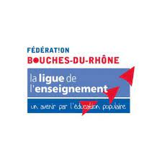*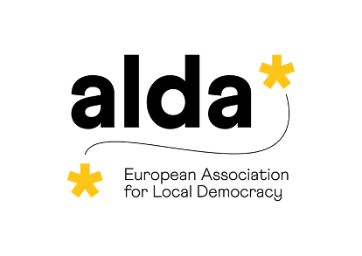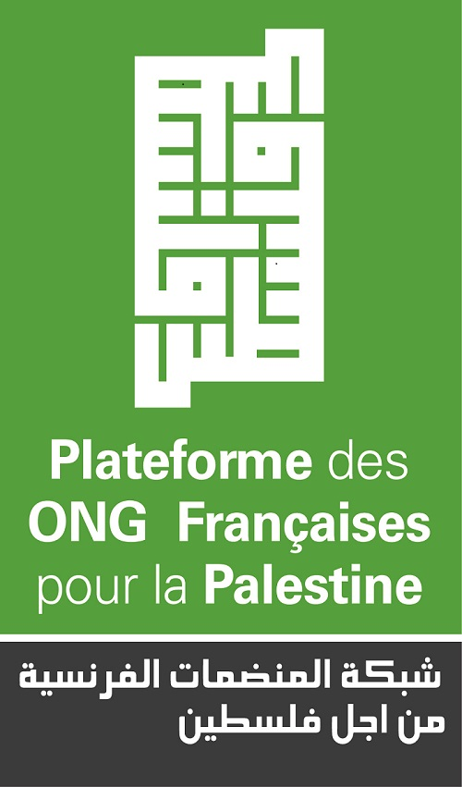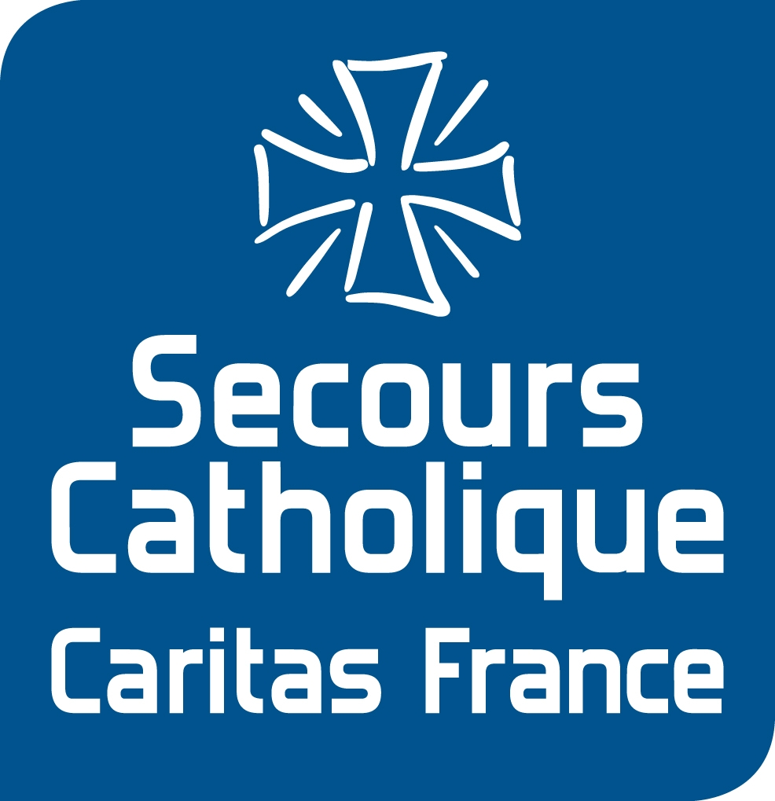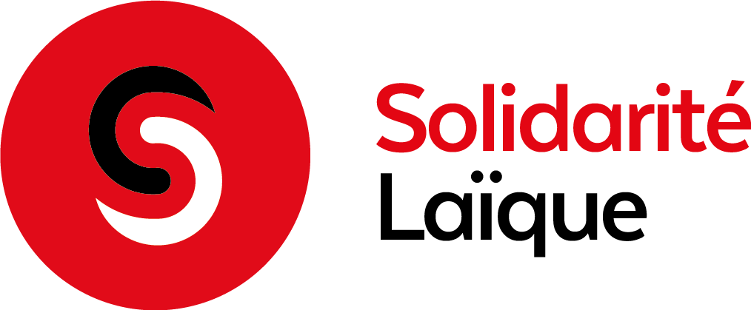*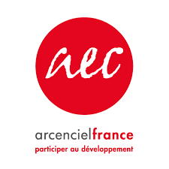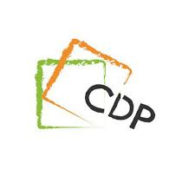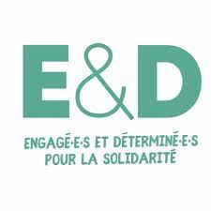**PARTNERS**

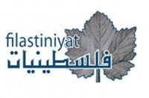

**CONTACT**

REF – Réseau Euromed France

80 rue de Paris, Montreuil (France)

+ 33 1 48 37 07 73

[contact@euromed-france.org](mailto:contact@euromed-france.org)

[www.euromed-france.org](http://www.euromed-france.org)

*This competition is carried out with the support of*

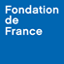 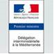 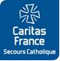

[](https://www.facebook.com/jeunesses.mediterraneennes)[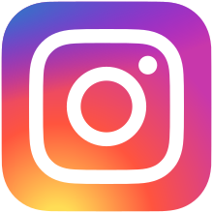](https://www.instagram.com/jeunessesmed/)*Med Youth on social networks*